**360 Photo Booth Sign Up**

Either sign up from our kiosk or use your own device.

1. Join PhotoBooth network
2. Scan QR Code or go to http://192.168.0.5

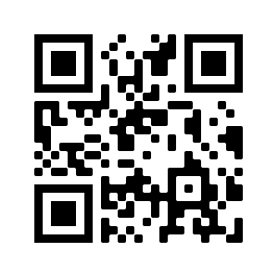

1. Fill out form
2. Wait For Name to be called
3. Create your 360 memory
4. Refresh and Download Now (From your own device)